**Sustainable Outreach And Universal**

**Leadership (SOUL) Limited**

**Software Requirement Specification (SRS)**

Of

**Staff Development Program(SDP) module**

For Implementation of

**Campus Management Software**

at

**World Skill Center (WSC)**

**Department - SOE**

**Table of Content**

A. Abstract 3

B. Introduction 3

C. Definition, Acronyms and Abbreviations 3

D. Overview of the Document 3

E. Scope of Education Module 4

F. WSC Participant ToT Process Flow 5

G. WSC Participant ToT Process Flow Description 5

H. List of Screens and their Descriptions 6

I. Training of Trainers 7

1. Masters 7

1.1 Department 7

1.2 Programs 10

1.3 Course 12

1.4 Topic 14

2. Admission 15

2.1 ToT Participant List 15

2.2 ToT Participant selection 19

2.3 ToT Participant reporting 20

3. Academics 22

3.1 Participant Group 22

3.2 Instructor 25

3.3 Participant Attendance 29

3.4 Participant Attendance Tool 30

3.5 Assignment 32

3.6 Assignment Upload 33

4. Examination 35

4.1 Assignment Declaration 35

4.2 Assignment Evaluation 38

4.3 Assignment Evaluation Tool 40

4.4 Assignment Result 42

4.5 Final Result Declaration Tool 44

# Abstract

Software Requirements Gathering is one of the first phases of system development. This phase results in the Software Requirements Specification (SRS) document, which must contain a complete, concise, high-quality description of the system being considered.

# Introduction

The World Skill Center (WSC) is a premier advanced skill training institute established by the Government of Odisha, Skill Development and Technical Education Department, through the Odisha Skill Development Authority (OSDA). The WSC will impart advanced skill training in eight trades from engineering and service sectors. WSC caters primarily to induct the best talent from ITIs and Polytechnics and train them to become globally employable in emerging areas such as "Industry 4.0". WSC is housed in a state-of-the-art, 18-storey, air-conditioned building with nearly half a million square feet of space in the heart of capital city of Bhubaneswar.

With the Implementation of campus management software for WSC the goal is to streamline the operations and functions of the campus by integrating various processes, such as admissions, course registration, academic progress tracking, and financial management, HRMS, Procurement and Inventory management, etc into a unified system. The implementation also aims at providing a user-friendly interface for all stakeholders, making it easier for them to access the necessary information and complete their tasks with ease. The modules to be covered during the implementation of the software includes:

|  |  |
| --- | --- |
| Participants Management Modules | Infrastructure Management |
| Academic System | Finance and Accounting System |
| Procurement & Inventory Management | Training and Placement |
| Human Resources Management System | Application Integration |

# Definition, Acronyms and Abbreviations

The following table explains the terms and abbreviations used in the document:

|  |  |
| --- | --- |
| **Abbreviation** | **Description** |
| SRS | Software Requirements Specification |
| SLCM | Participant Life Cycle Management |
| R | Rename - When a field is Renamed |
| N | New - When a New field is Added |
| D | Delete - When an Existing field is Deleted |
| NA | Not Applicable |

# Overview of the Document

This requirement document provides a detailed overview of the functional requirements of a project. It serves as a communication tool between stakeholders, including developers, project managers, and end-users. The purpose of this requirement document is to define and document the project's objectives, scope, and expectations, and to ensure that all stakeholders have a clear understanding of what the project entails.

This document covers all the functional requirements of the **Training of Trainers (ToT) module** of ERP Product. This module helps in organizing the entire Tot set-up, such as ToT participant Database, ToT Application Form, Fee Structure, Course Enrollment, ToT participant Attendance, Exam Evaluation, Certificate Generation, etc.

# Scope of Education Module

* Courses and Subjects, Timetable preparation and management  ▪
* Class occurrence monitoring
* Class Attendance of Participants (Face recognition or any other automated mode).    ▪
* Results Analysis after declaration of results by WSC ▪
* Participants Feedback mechanism on quality of teaching learning ▪ Internship, Training, Apprentice ▪
* Re-Admission Process after discontinuing in studies ▪
* Participants Back paper tracking etc.
* Participants Profile.  :Personal Information, Contact Details, Academic Details ▪
* Issue of Identity Card.  ▪
* Biometric Attendance (Face recognition) ▪
* Hostel Management (Hostel seat allotment, attendance, fees etc) ▪
* Scholarships.  ▪
* Rewards and achievements.  ▪
* Participants’ Evaluation/remarks of Faculty.  ▪
* Parent Enquiry/Alert/Messaging Management.  ▪
* Messaging System  ▪
* Participants Grievance System etc.

Following functionalities are covered in this SRS document:

* **Tot participant Details**
* **ToT participant Attendance**
* **ToT Exam Conducting**
* **Result Publication**
* **Certificate Generation**

# WSC Participant ToT Process Flow

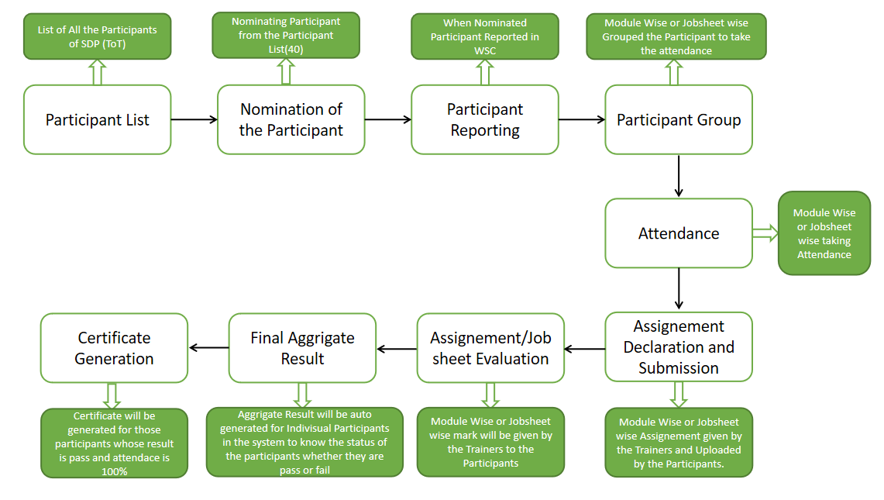

Figure 1 : ToT Process Flow

# WSC Participant ToT Process Flow Description

**participant list creation**

This allows the user to enter and maintain records of participant who are eligible for the ToT program in the system.

**Course selection**

This allows the user to create and maintain records of course(s) that will be under the ToT program.

**Module creation**

This allows the user to create and maintain records of module(s) that will be under the ToT program.

**Sub-module creation**

This allows the user to create and maintain records of sub-module(s) that will be under the ToT program.

**Participant selection**

This allows the user to select participant for a ToT program from the records maintained in the participant list.

**ToT Participant reporting**

This allows the user to mark a participant as present after they have reported on the day of reporting.

**Participant record creation**

This allows the user to create a record of a participant as a Participant under the ToT program which will later be used to do program enrollment.

**Course enrollment**

This allows the user to enroll a participant in to a particular course for their training.

**Module enrollment**

This allows the user to enroll a participant in to a particular module w.r.t. the courses for their training.

**Recording attendance in every class**

This allows the user to record attendance of participant during each class under the ToT program.

**Assignment Declaration & Submission**  
This allows the user to declare various assignments/Job sheets according to a particular course and academic year.

**Job sheet Evaluation**

In this process module wise or Job sheet wise marks will be given by the Trainers to the participants.

**Aggrigate Final Result**

This process includes the final result of the participants for their Training Programs

**Generate Certificate**

This allows the user to generate a certificate for the participant after they have met all the criteria’s required for a certificate.

# List of Screens and their Descriptions

The following tables lists the pages used in ToT module :

|  |  |  |
| --- | --- | --- |
| **Sl no** | **Screen Name** | **Description** |
|  | Department | A Department is a specialized functional area or a division within an organization. |
|  | Programs | The Programs document will hold all the data related to the programs. |
|  | Course | A course will have an educational curriculum defined by user institute to streamline the learning process. |
|  | Topic | **A Topic is a sub unit of a Module and will contain all the contents related to the topic.** |
|  | Participant Group | The Participant Group allows you to create a group of Participants for different classes for the ongoing Academic Year. |
|  | Instructor | An instructor is an employee who will be responsible for teaching a particular topic or course to the Participants. |
|  | Participant Attendance | The Participant Attendance allows you to keep track and mark the attendance of a Participant for a day. Attendance records can be created against Participants on a daily basis. |
|  | Participant Attendance Tool | The Participant Attendance Tool allows user to bulk update the Attendance for Participants based on Participant Group and Course Schedule. |
|  | Assignment Declaration & Submission | The Assignment Declaration will allow user to declare an exam for various Job sheets or modules with respect to a course |
|  | Assignment Evaluation | In Assignment Evaluation Process marks will be given by the Trainers. |
|  | Final Assignment Result | Final Assignment Result is used to evaluate the final assignment of a participant for a particular course. |
|  | Final result declaration tool | Final Result Declaration Tool is used to declare the final exam results for a particular group/batch of Participant. |
|  | ToT participant list | This screen is used for creating and maintaining records of eligible participant |
|  | ToT participant selection | This screen is used for selecting participant for training's from the maintained ToT participant list |
|  | ToT participant reporting | This screen is used for marking a participant as present on the date of reporting |

# Training of Trainers

Following are the screens used to achieve the functionalities of ToT.

## Masters

### Department

**General Description**

The following table describes overall information about this screen:

|  |  |  |
| --- | --- | --- |
| **Description** | | 1. A Department is a specialized functional area or a division within an organization. 2. User will configure the Departments, set Leave Block List and also Leave and Expense Approvers for the same. 3. Department is a tree-structured master, which means user can create parent departments and sub-departments as shown below |
| **Navigation** | Home > Admission > Masters > Department | |
| **Pre-requisites** | The system should have records in the following screen   1. Company 2. Leave Block List | |
| **Existing Screen Name** | Department | |
| **New Screen Name** | No change | |

**Screenshot**

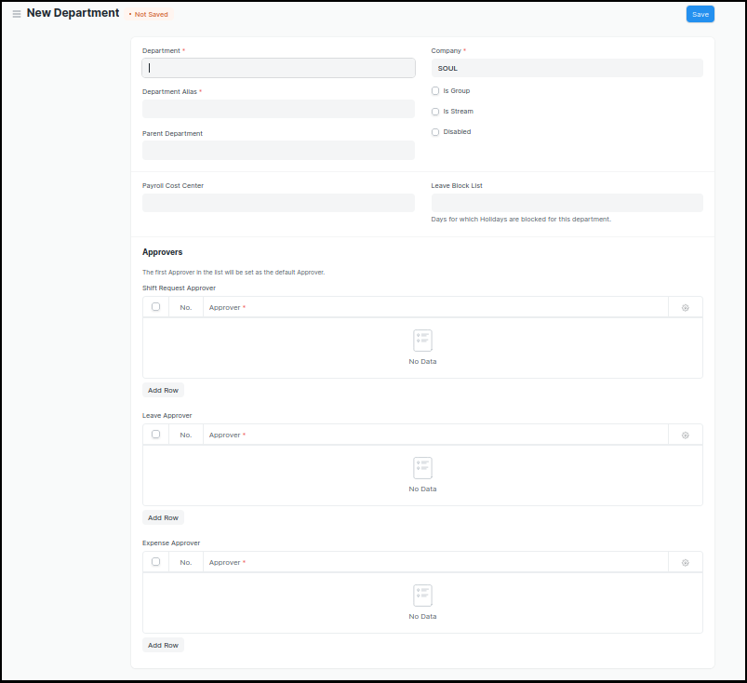

Figure 2 : Department Screen

**Field List**

The following table describes the UI fields present in this screen :

|  |  |  |  |  |  |  |
| --- | --- | --- | --- | --- | --- | --- |
| **ID** | **Field Name** | **Field Type** | **Mandatory** | **Validation/ Action** | **Remarks** | **R/N/D** |
| 1 | Department | Text Field | Yes |  |  |  |
| 2 | Parent Department | Link Field |  |  |  |  |
| 3 | Company | Link Field | Yes | Link Fields to Master Screen Company | Default company name will be fetched |  |
| 4 | Is Group | Checkbox |  | If checked the department will be grouped under a parent department |  |  |
| 5 | Is Stream | Checkbox |  | If checked the department will be considered as a stream E.g (Commerce, Arts, Etc) |  |  |
| 6 | Disabled | Checkbox |  | If checked, the department record will not be able to visible in any transaction |  |  |
| 7 | Payroll Cost Center | Link Field |  |  | Not Applicable for Admission Module |  |
| 8 | Leave Block List | Link Field |  |  | Not Applicable for Admission Module |  |
| 10 | Leave Approver | Table |  |  | Not Applicable for Admission Module |  |
| 11 | Expense Approver | Table |  |  | Not Applicable for Admission Module |  |
| 12 | Shift Request Approver | Table |  |  | Not Applicable for Admission Module |  |

**User: Roles & Permission**

The following table describes the users and their roles and permissions for the screens :

|  |  |  |  |  |  |  |  |  |
| --- | --- | --- | --- | --- | --- | --- | --- | --- |
| **ID** | **Role** | **Read** | **Write** | **Create** | **Delete** | **Submit** | **Cancel** | **Amend** |
| 1 | ToT coordinator/director | Yes | No | No | No | NA | NA | NA |
| 2 | ToT coordinator/administrator | Yes | No | No | No | NA | NA | NA |
| 3 | ToT assistant coordinator/trainer | Yes | No | No | No | NA | NA | NA |

## 

### Programs

**General Description**

The following table describes overall information about this screen:

|  |  |
| --- | --- |
| **Description** | 1. A program will have an educational curriculum defined by user institute to streamline the learning process and goals in each subject or module. 2. For example, Mechatronics would be a program taught at the institute that will have various modules within |
| **Navigation** | Home > Admission >Masters > Programs |
| **Pre-requisites** | Department |
| **Existing Screen Name** | Programs |
| **New Screen Name** | Course |

**Screenshot**

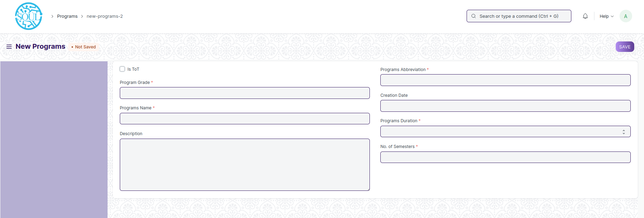Figure 3 : Programs Screen

**Field List**

The following table describes the UI fields present in this screen :

|  |  |  |  |  |  |  |
| --- | --- | --- | --- | --- | --- | --- |
| **ID** | **Field Name** | **Field Type** | **Mandatory** | **Validation/ Action** | **Remarks** | **R/N/D** |
| 1 | Program Grade | Link Field | Yes | Links with Program Grade Screen |  | (**R**) Course Grade |
| 2 | Is ToT | Checkbox |  | Checking this checkbox will mark the Participant profile that will be created as one belonging to a ToT participant |  |  |
|  |  |  |  |  |  |  |
| 3 | Programs Name | Data | Yes |  |  | **(R**) Course Name |
| 4 | Department | Link Field | Yes | Links with Department Screen |  |  |
| 5 | Description | Small Text |  |  |  |  |
| 6 | Programs Abbreviation | Text | Yes |  |  | 1. Course   Abbreviation |
| 7 | Creation Date | Date |  |  |  |  |
| 8 | Course Duration | Number | Yes |  | In no. Of Days | **(N)** |

**User: Roles & Permission**

The following table describes the users and their roles and permissions for the screens :

|  |  |  |  |  |  |  |  |  |
| --- | --- | --- | --- | --- | --- | --- | --- | --- |
| **ID** | **Role** | **Read** | **Write** | **Create** | **Delete** | **Submit** | **Cancel** | **Amend** |
| 1 | ToT coordinator/director | Yes | Yes | Yes | No | NA | NA | NA |
| 2 | ToT coordinator/administrator | Yes | Yes | Yes | No | NA | NA | NA |
| 3 | ToT assistant coordinator/trainer | Yes | No | No | No | NA | NA | NA |
| 4 | ToT participant | Yes | No | No | No | NA | NA | NA |

## 

### Course

**General Description**

The following table describes overall information about this screen:

|  |  |
| --- | --- |
| **Description** | 1. A module can be considered as a subject or a part of an educational program which is to be taught for a term 2. For example, if for a particular term, Mechatronics is a Course taught in the institute, then Pneumatics would be a Module covered under the Course. 3. A module will have a set of sub module that are to be covered under its scope. |
| **Navigation** | Home > Admission > Masters > Module |
| **Pre-requisites** | 1. Department 2. Course Grade 3. Course 4. Assessment Criteria |
| **Existing Screen Name** | Course |
| **New Screen Name** | Module |

**Screenshot**

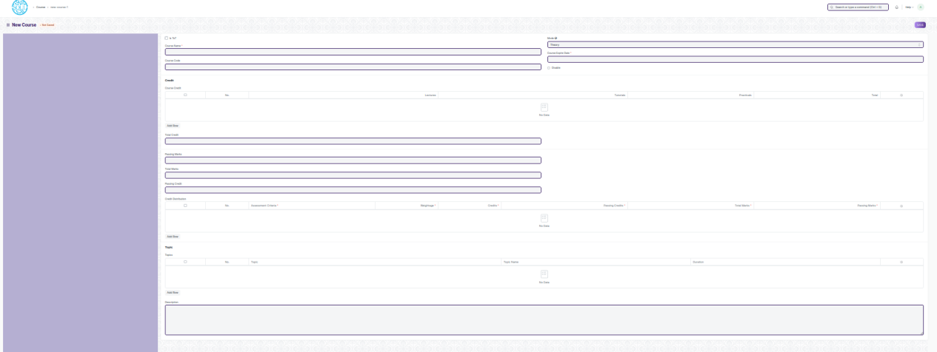

Figure 4 : Course Screen

**Field List**

The following table describes the UI fields present in this screen :

|  |  |  |  |  |  |  |
| --- | --- | --- | --- | --- | --- | --- |
| **ID** | **Field Name** | **Field Type** | **Mandatory** | **Validation/ Action** | **Remarks** | **R/N/D** |
| 1 | Course Name | Text | Yes |  |  | ( R ) Module Name |
| 2 | Is ToT | Checkbox |  | Checking this checkbox will mark the Participant profile that will be created as one belonging to a ToT participant |  |  |
| 3 | Course Code | Text | Yes |  |  | ( R ) Module Code |
| 4 | Mode | Dropdown |  | Theory  Practical  Both |  |  |
| 5 | Course Expire Date | Date | Yes |  |  | ( R ) Module Expire Date |
| 6 | Disable | Checkbox |  | If Checked, then course should not be visible in any transaction. |  |  |
| **Course Credit** | | | | | | |
| 7 | Lectures | Float |  |  |  | ( D ) |
| 8 | Tutorials | Float |  |  |  | ( D ) |
| 9 | Pacticals | Float |  |  |  | ( D ) |
| 10 | Total | Float |  | Total Will be auto calculate  The sumof L, T & P |  | ( D ) |
| 11 | Total Credit | Float |  | Total Credit Will be auto calculate  the sum of L, T & P |  | ( D ) |
| 12 | Passing Marks | Float |  |  |  |  |
| 13 | Total Marks | Float |  |  |  |  |
| 14 | Passing Credit | Float |  |  |  | ( D ) |
| **Credit Distribution** | | | | | | |
| 15 | Assessment Criteria | Link Field | Yes |  |  |  |
| 16 | Weightage | Percentage | Yes |  |  |  |
| 17 | Credits | Float | Yes |  |  | ( D ) |
| 18 | Passing Credits | Float | Yes |  |  | ( D ) |
| 19 | Total Marks | Float | Yes | Weightage will be auto fetched in Total Marks |  |  |
| 20 | Passing Marks | Float | Yes |  |  |  |
| **Topic** | | | | | | |
| 21 | Topic | Link Field |  | Links with Topic Screen |  |  |
| 22 | Topic Name | Text |  | Auto fetch the Topic Name when topic is entered |  |  |
| 23 | Duration | Duration |  |  |  |  |
| 24 | Attach lesson plan | Attach |  | 1. On attachment a dialogue box will be popup where user can attach the files, take the picture with the help camera and can link any URL. 2. If photos or images attached then the size will be maximum 200 kb. |  |  |
| 25 | Action/ Add to ToT Program | Action Button |  | A popup will open, you need to choose the Program name, where you want to Link . |  |  |

**User: Roles & Permission**

The following table describes the users and their roles and permissions for the screens :

|  |  |  |  |  |  |  |  |  |
| --- | --- | --- | --- | --- | --- | --- | --- | --- |
| **ID** | **Role** | **Read** | **Write** | **Create** | **Delete** | **Submit** | **Cancel** | **Amend** |
| 1 | ToT coordinator/director | Yes | Yes | Yes | Yes | NA | NA | NA |
| 2 | ToT coordinator/administrator | Yes | Yes | Yes | Yes | NA | NA | NA |
| 3 | ToT assistant coordinator/trainer | Yes | No | No | No | NA | NA | NA |
| 4 | ToT participant | Yes | No | No | No | NA | NA | NA |

### Topic

**General Description**

|  |  |
| --- | --- |
| **Description :** | **A Topic is a sub unit of a Module and will contain all the contents related to the topic.** |
| **Path :** | Home > Admission > Masters > Topic |
| **Pre-requisites :** |  |
| **Existing Screen Name** | Topic |
| **New Screen Name** | No change |

**Screenshot**

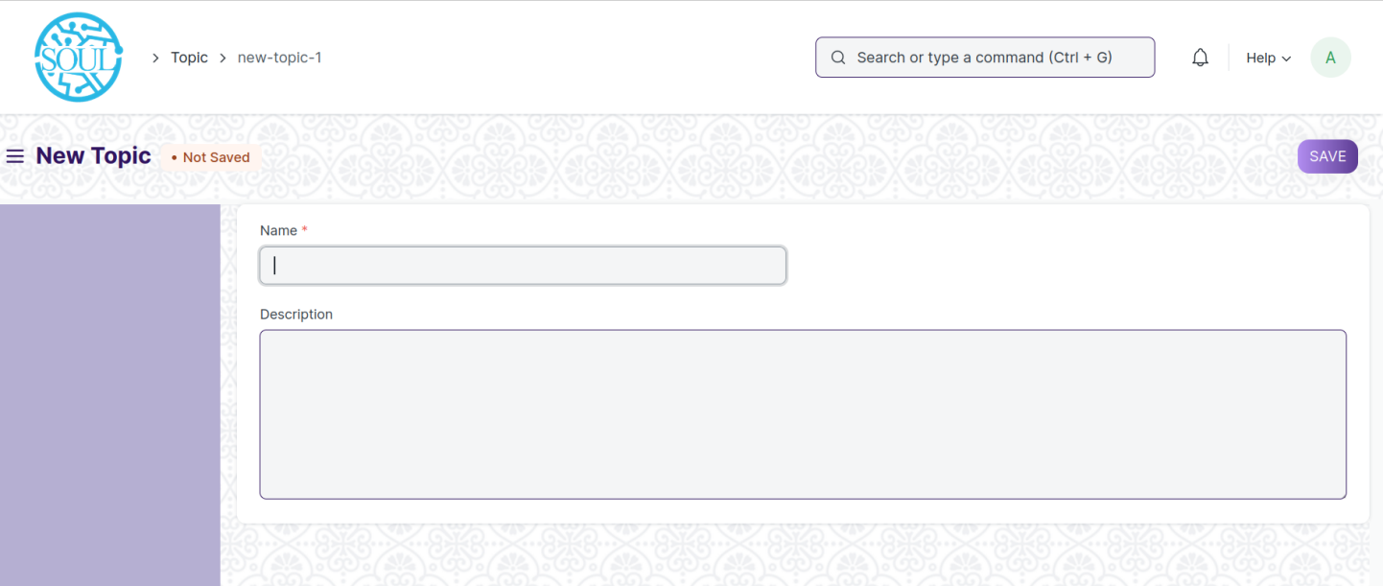Figure 6 : Topic Screen

**Field List:**

The following table describes the UI fields present in this screen :

|  |  |  |  |  |  |  |
| --- | --- | --- | --- | --- | --- | --- |
| **ID** | **Field Name** | **Field Type** | **Mandatory** | **Validation/ Action** | **Remarks** | **R/N/D** |
| 1 | Name | Data | Yes |  |  |  |
| 2 | Topic content | Table |  |  |  |  |
| 3 | Description | Small Text |  |  |  |  |
| 4 | Hero Image | Attach Image |  |  |  |  |

**User: Roles & Permission :**

The following table describes the users and their roles and permissions for the screens :

|  |  |  |  |  |  |  |  |  |
| --- | --- | --- | --- | --- | --- | --- | --- | --- |
| **ID** | **Role** | **Read** | **Write** | **Create** | **Delete** | **Submit** | **Cancel** | **Amend** |
| 1 | ToT coordinator/director | Yes | Yes | Yes | Yes | NA | NA | NA |
| 2 | ToT coordinator/administrator | Yes | Yes | Yes | Yes | NA | NA | NA |
| 3 | ToT assistant coordinator/trainer | Yes | No | No | No | NA | NA | NA |

## Admission

## ToT Participant List

**General Description**

|  |  |
| --- | --- |
| **Description** | This screen is used to enter and maintain the details of eligible participant for the ToT Program.  This screen contains the list of all participant that could ever qualify for TOT under DTET |
| **Navigation** | NA |
| **Pre-requisites** | NA |
| **Existing Screen Name** | ToT participant list |
| **New Screen Name** | No change |

### **Screenshot**

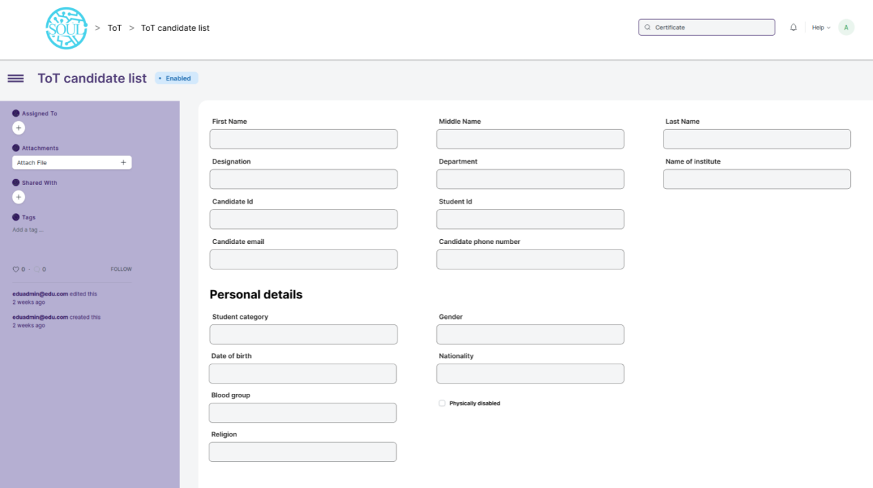

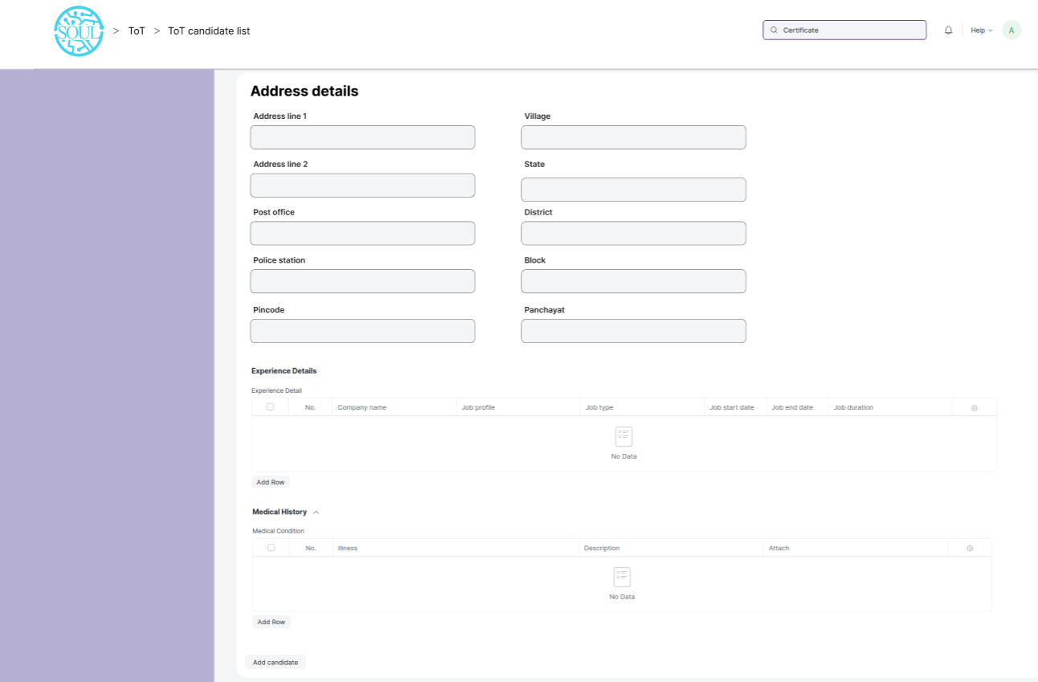

Figure 30 : ToT participant list Screen

### **Field List**

The “ToT participant list” screen shall consist of the following fields:

|  |  |  |  |  |  |  |
| --- | --- | --- | --- | --- | --- | --- |
| ToT participant list | | | | | | |
| **ID** | **Field Label** | **Field Type** | **Mandatory** | **Validation/Action** | **Remarks** | **R/N/D** |
| 1 | First Name | Text | Yes |  |  |  |
| 2 | Middle Name | Text |  |  |  |  |
| 3 | Last Name | Text |  |  |  |  |
| 4 | Designation | Text |  |  |  |  |
| 5 | Department | Text |  |  |  |  |
| 6 | Name of institute | Text |  |  |  |  |
| 7 | participant ID | Text |  |  |  |  |
| 9 | Participant email | Text |  | Email validation need to be there |  |  |
| 10 | Participant phone number | Text |  | Phone number need to be restricted to 10 digit |  |  |
| **Personal Details** | | | | | | |
| 11 | Participant Category | Link Field |  | Links to Participant Category Screen and  Options are  ST  SC  OBC  General |  |  |
| 13 | Date of Birth | Date |  |  |  |  |
| 14 | Blood Group | Dropdown |  | A +ve  B +ve  AB +ve  O +ve  A -ve  B -ve  AB -ve  O -ve |  |  |
| 15 | Religion | Link |  |  |  |  |
| 16 | Gender | Link |  |  |  |  |
| 17 | Nationality | Text |  |  |  |  |
| 18 | Physically Disabled | Checkbox |  |  |  |  |
| **Address details** | | | | | | |
| 19 | Address Line 1 | Text |  |  |  |  |
| 20 | Address Line 2 | Text |  |  |  |  |
| 21 | Post Office | Text |  |  |  |  |
| 22 | Police Station | Text |  |  |  |  |
| 23 | Pincode | Text |  |  |  |  |
| 24 | Village | Text |  |  |  |  |
| 25 | State | Text |  |  |  |  |
| 26 | District | Text |  |  |  |  |
| 27 | Block | Text |  |  |  |  |
| 28 | Panchayat | Text |  |  |  |  |
| **Experience Details** | | | | | | |
| 44 | Office/Company/Institute name | Text |  |  |  |  |
| 45 | Job profile | Text |  |  |  |  |
| 46 | Job type | Dropdown |  | 1. Permanent   2. Internship  3. Contractual  4. Non-contractual |  |  |
| 47 | Job start date | Text |  |  |  |  |
| 48 | Job end date | Text |  |  |  |  |
| 49 | Job duration | Text |  |  |  |  |
| 50 | Country | Link |  |  |  |  |
| **Medical History** | | | | | | |
| 79 | Illness | Text |  |  |  |  |
| 80 | Description | Text |  |  |  |  |
| 81 | Attach | Attachment |  | 1. On attachment a dialogue box will be popup where user can attach the files, take the picture with the help camera and can link any URL. 2. If photos or images attached then the size will be maximum 200 kb. |  |  |

### **User: Roles & Permission**

The following table describes the users and their roles and permissions for the screens :

|  |  |  |  |  |  |  |  |  |
| --- | --- | --- | --- | --- | --- | --- | --- | --- |
| **ID** | **Role** | **Read** | **Write** | **Create** | **Delete** | **Submit** | **Cancel** | **Amend** |
| 1 | ToT coordinator/director | Yes | Yes | Yes | Yes | NA | NA | NA |
| 2 | ToT coordinator/administrator | Yes | Yes | Yes | No | NA | NA | NA |
| 3 | ToT assistant coordinator/trainer | Yes | No | No | No | NA | NA | NA |

## ToT Participant selection

**General Description**

|  |  |
| --- | --- |
| **Description** | This screen is used to select and maintain list of participant chosen for a particular ToT training program by WSC or DTET. |
| **Navigation** | NA |
| **Pre-requisites** | 1. ToT participant list |
| **Existing Screen Name** | ToT participant selection |
| **New Screen Name** | No change |

### **Screenshot**

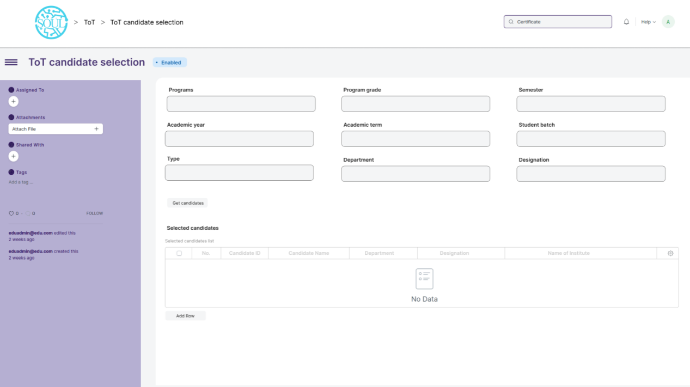

Figure 31 : ToT participant selection

### **Field List**

The “ToT participant selection” screen shall consist of the following fields:

|  |  |  |  |  |  |  |
| --- | --- | --- | --- | --- | --- | --- |
| **ToT participant selection** | | | | | | |
| **ID** | **Field Label** | **Field Type** | **Mandatory** | **Validation/Action** | **Remarks** | **R/N/D** |
| 1 | Course | Link Field | Yes | Links to Programs Screen |  | N |
| 2 | Course Grade grade | Text Field | Yes | Links to Program Grade Screen |  | N |
| 4 | Academic year | Link | Yes | Links to Academic Year Screen |  | N |
| 5 | Academic term | Link Field | Yes | Links to Academic Term Screen and auto fetched on the basis of Academic Year | Need to be hidden | N |
| 6 | Participant batch | Link Field |  | Links to Participant Batch Screen |  | N |
| 7 | **Selected Participant** | Table |  | Description of the table is given below |  | N |
| **Selected Participant** | | | | | | |
| 11 | Participant ID | Link Field |  | Links to Participant List Screen |  | N |
| 12 | Participant name | Text Field |  | Auto fetched from Participant List screen |  | N |
| 13 | Department | Text Field |  | Auto fetched from Participant List screen |  | N |
| 14 | Designation | Text Field |  | Auto fetched from Participant List screen |  | N |
| 15 | Name of institute | Text Field |  | Auto fetched from Participant List screen |  | N |

### **User: Roles & Permission**

The following table describes the users and their roles and permissions for the screens :

|  |  |  |  |  |  |  |  |  |
| --- | --- | --- | --- | --- | --- | --- | --- | --- |
| **ID** | **Role** | **Read** | **Write** | **Create** | **Delete** | **Submit** | **Cancel** | **Amend** |
| 1 | ToT coordinator/director | Yes | Yes | Yes | Yes | NA | NA | NA |
| 2 | ToT coordinator/administrator | Yes | Yes | Yes | No | NA | NA | NA |
| 3 | ToT assistant coordinator/trainer | Yes | No | No | No | NA | NA | NA |

## ToT Participant reporting

**General Description**

|  |  |
| --- | --- |
| **Description** | This screen is used for marking a participant/trainee as present after they have reported on the day of reporting |
| **Navigation** | NA |
| **Pre-requisites** | 1. ToT participant selection |
| **Existing Screen Name** | ToT participant reporting |
| **New Screen Name** | No change |

### **Screenshot**

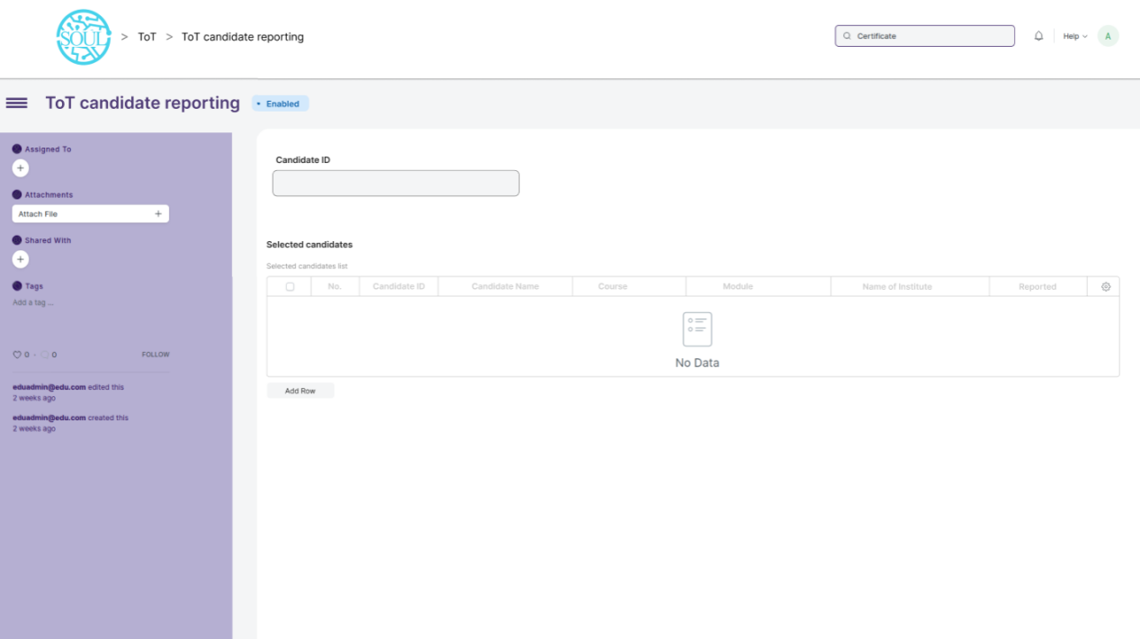

Figure 32 : ToT participant reporting

### **Field List**

The “ToT participant reporting” screen shall consist of the following fields:

|  |  |  |  |  |  |  |
| --- | --- | --- | --- | --- | --- | --- |
| **ID** | **Field Label** | **Field Type** | **Validation/Actions** | **Mandatory** | **Remarks** | **R/N/D** |
| 1 | Participant Selection Id | Link Field | Links to Participant Selection Screen | Yes |  | N |

|  |  |  |  |  |  |  |
| --- | --- | --- | --- | --- | --- | --- |
| Personal Detiails | | | | | | |
| ID | Field Label | Field Type | Validation/Actions | Mandatory | Remarks | R/N/D |
| 1 | Participant ID | Link Field | Auto fatched when Participant Selection Id is entered | Yes |  | N |
| 2 | Participant name | Text | Auto fatched when Participant Selection Id is entered |  |  | N |
| 3 | Department | Text | Auto fatched when Participant Selection Id is entered |  |  | N |
| 4 | Designation | Text | Auto fatched when Participant Selection Id is entered |  |  | N |
| 5 | Name of institute | Text | Auto fatched when Participant Selection Id is entered |  |  | N |
| 6 | Reported | Checkbox | When a participant reported, then it need to be checked and user need to be save the record every time, when all the participant will reported, the records need to submitted by the user. |  |  | N |

**Note:** This is a submitted screen.

### **User: Roles & Permission**

The following table describes the users and their roles and permissions for the screens :

|  |  |  |  |  |  |  |  |  |
| --- | --- | --- | --- | --- | --- | --- | --- | --- |
| **ID** | **Role** | **Read** | **Write** | **Create** | **Delete** | **Submit** | **Cancel** | **Amend** |
| 1 | ToT coordinator/director | Yes | Yes | Yes | Yes | NA | NA | NA |
| 2 | ToT coordinator/administrator | Yes | Yes | Yes | No | NA | NA | NA |
| 3 | ToT assistant coordinator/trainer | Yes | No | No | No | NA | NA | NA |

## Academics

## Participant Group

**General Description**

The following table describes overall information about this screen:

|  |  |
| --- | --- |
| **Description** | 1. Participant group is a collection of participant who share common characteristics or attributes. 2. These characteristics may include factors such as the participant academic level, course of study, modules of study, or other specific criteria used to group Participants together 3. User will fill out the necessary information for the participant group, such as a name for the group,batch, course and the criteria that will be used to add participant to the group for creation of participant group. |
| **Navigation** | Home > Academics > Group & Schedules > Participant Group |
| **Pre-requisites** | 1. Participant 2. Program Enrollment 3. Course Enrollment 4. Participant Batch Name 5. Participant Category 6. Instructor |

**Screenshot**

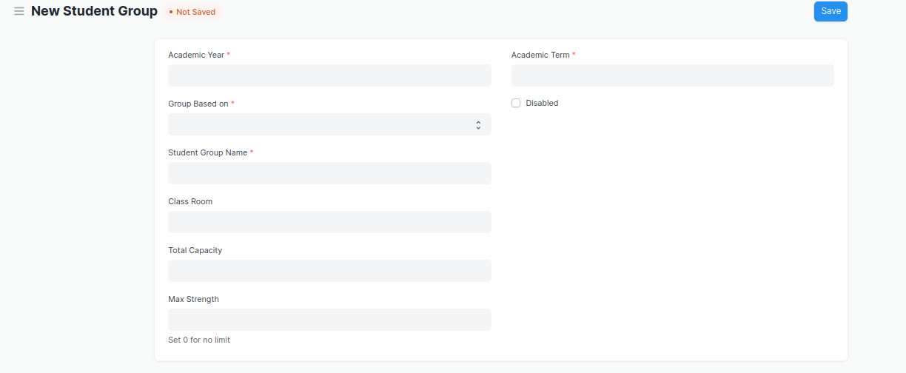

Figure 8 :Participant Group screen

**Field List**

The following table describes the UI fields present in this screen :

|  |  |  |  |  |  |  |
| --- | --- | --- | --- | --- | --- | --- |
| **ID** | **Field Name** | **Field Type** | **Validation/Action** | **Mandatory** | **Remarks** | **R/N/D** |
| 1 | Academic Year | Link Field | Value Fetched From the Academic Year list and will show in a drop down. User will select one of them. | Yes |  |  |
| 2 | Group Based on | Drop down | Options : Batch Course Activity  Mentor Communication | Yes |  | (D)Combined Course |
| 3 | Participant Group | Text | User will give input | Yes |  |  |
| 4 | Max Strength | Number | User will give input |  |  |  |
| 5 | Academic Term | Link Field | Link Field to Academic Term Screen and filtered applied w.r.t Academic Year |  |  |  |
| 6 | Program | Link Field | Value will be fetched from Program list in a drop down.User will select one value. |  |  | ( R ) Course |
| 7 | Batch | Link Field | Batch field will be visible if user select Participant group based upon batch |  |  |  |
| 8 | Participant Category | Link Field | Value will be fetched from Participant Category list in drop down. User will select one value. |  |  |  |
| 9 | Course | Link Field | Value will be fetched from course list , and course field will be visible when a user select group based on courses. |  |  | ( R ) Module |
| 10 | Disabled | Check box | If Checked, the Participant group record will not be able to visible in any respective transaction |  |  |  |
| 11 | Get Participants | Button | 1. User will click the Get Participants Button.   2. On click list of Participants with respect to the course will auto fetched in the Participants table |  |  |  |
| 12 | **Participants** | Table | On clicking Get Participants button, all the Participants will be fetched according to the inputted parameters. And the description of the table is given below. |  |  |  |
| 13 | **Instructors** | Table | * Instructor list need to be selected according to the inputted parameters . * when Participant group based on course selected then only those instructor list will be on drop down w.r.t. the entered course. * Description of the table is given below. |  |  | ( R )Trainer |

|  |  |  |  |  |  |  |
| --- | --- | --- | --- | --- | --- | --- |
| **Participant Group Participant** | | | | | | |
| **ID** | **Field Name** | **Field Type** | **Validation/Action** | **Mandatory** | **Remarks** | **R/N/D** |
| 1 | Participant | Link Field | Those participant will come who are belongs to the particular course, and In group based up on activity. | Yes |  |  |
| 2 | Participant Name | Text | Participant Name will auto fetched when Participant Id fetched in Participant Field |  |  |  |
| 3 | Group Roll Number | Number | Roll will auto create |  |  |  |
| 4 | Active | Check box | If unchecked then this Participant will not visible in any transaction |  |  |  |

|  |  |  |  |  |  |  |
| --- | --- | --- | --- | --- | --- | --- |
| **Participant Group Instructor** | | | | | | |
| **ID** | **Field Name** | **Field Type** | **Validation/Action** | **Mandatory** | **Remarks** | **R/N/D** |
| 1 | Instructors | Link Field | Value will fetch from Instructor list.User will select value. | Yes |  | (R) Trainer |
| 2 | Instructor Name | Read only | After selecting the instructor id , this value will be auto filled. |  |  | (R) Trainer Name |
| 3 | Course | Link Field | If course wise group created, then those course will come whose name selected in the above course field | Yes |  | (R) Module |

**Users: Roles and Permissions**

The following table describes the users and their roles and permissions for the screens :

|  |  |  |  |  |  |  |  |  |
| --- | --- | --- | --- | --- | --- | --- | --- | --- |
| **ID** | **Role** | **Read** | **Write** | **Create** | **Delete** | **Submit** | **Cancel** | **Amend** |
| 1 | ToT coordinator/director | Yes | Yes | Yes | Yes | NA | NA | NA |
| 2 | ToT coordinator/administrator | Yes | Yes | Yes | Yes | NA | NA | NA |
| 3 | ToT assistant coordinator/trainer | Yes | Yes | Yes | Yes | NA | NA | NA |

## Instructor

**General Description**

The following table describes overall information about this screen:

|  |  |
| --- | --- |
| **Description** | 1. An instructor is a teacher, tutor, or a professor who will be responsible for teaching a particular topic or course to the Participants. 2. This screen will be used to maintain the Instructor Log in the form of a list of topics/courses covered by the Instructor. This log will have the entire history of the courses taught by the Instructor. |
| **Navigation** | Home > Admission > Participant & Instructor > Instructor |
| **Pre-requisites** | 1. User 2. Employee 3. Department 4. Programs 5. Semester 6. Course 7. Academic Year 8. Academic Term |

**Screenshot**

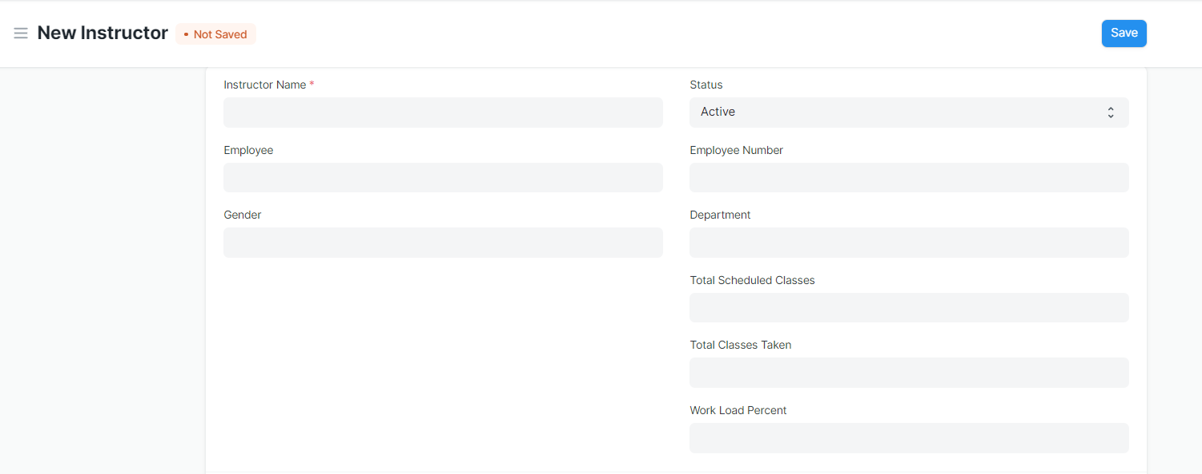

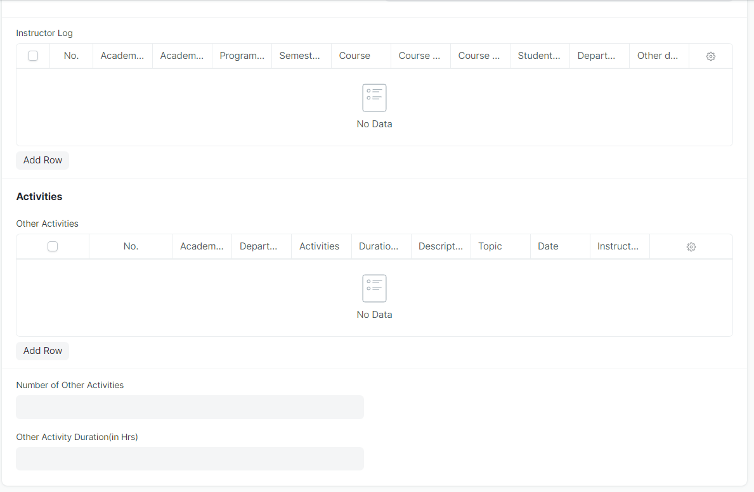

Figure 11 : Instructor Screen

**Field List**

The following table describes the UI fields present in this screen :

|  |  |  |  |  |  |  |
| --- | --- | --- | --- | --- | --- | --- |
| **ID** | **Field Name** | **Field Type** | **Mandatory** | **Validation/Action** | **Remarks** | **R/N/D** |
| 1 | Instructor Name | Text | Yes | Auto fetch the detail when employee id entered |  | (R) Trainer Name |
| 2 | Employee | Link Field |  | Linked to Employee Screen |  |  |
| 3 | Gender | Link Field |  | Auto fetch the detail when employee id entered |  |  |
| 4 | Status | Dropdown |  |  |  |  |
| 5 | Naming Series | Dropdown |  |  |  |  |
| 6 | Employee Number | Text |  | Auto fetch the detail when employee id entered |  |  |
| 7 | Department | Link Field |  | Auto fetch the detail when employee id entered |  |  |
| 8 | Total Scheduled Classes | Number |  |  |  |  |
| 9 | Total Classes Taken | Number |  |  |  |  |
| 10 | Work Load Percent | Float |  |  |  |  |
| 11 | Image | Attach Image |  | 1. On attachment a dialogue box will be popup where user can attach the image, take the picture with the help camera and can link any URL. 2. If photos or images attached then the size will be maximum 200 kb. |  |  |
| 12 | Academic Year | Link Field | Yes |  |  |  |
| 13 | Academic Term | Link Field |  | Academic Term is filtered on the basis of Academic Year |  |  |
| 14 | Department | Link Field |  |  |  |  |
| 15 | Programs | Link Field | Yes |  |  | (R) Course |
| 16 | Semester | Link Field | Yes | Semester is filtered on the basis of Programs |  |  |
| 17 | Course | Link Field |  | Course is filtered on the basis of semester |  | (R) Module |
| 18 | Course code | Link Field |  | Auto fetch the detail when course entered |  | (R) Module Code |
| 19 | Course Name | Text |  | Auto fetch the detail when course entered |  | (R) Module Name |
| 20 | Participant Group | Link Field |  |  |  |  |
| 21 | Other details | Small Text |  |  |  |  |
| 22 | Academic Year | Link Field |  | Linked to Academic year screen |  |  |
| 23 | Department | Link Field |  | Linked to Department Screen |  |  |
| 24 | Activities | Dropdown |  |  |  |  |
| 25 | Date | Date |  |  |  |  |
| 26 | Duration(in Hrs ) | Float |  |  |  |  |
| 27 | Description | Long Text |  |  |  |  |
| 28 | Topic | Text |  |  |  |  |
| 29 | Instructor Name | Text |  |  |  | (R) Trainer Name |

**Users: Roles & Permission**

The following table describes the users and their roles and permissions for the screens :

|  |  |  |  |  |  |  |  |  |
| --- | --- | --- | --- | --- | --- | --- | --- | --- |
| **ID** | **Role** | **Read** | **Write** | **Create** | **Delete** | **Submit** | **Cancel** | **Amend** |
| 1 | ToT coordinator/director | Yes | No | No | No | NA | NA | NA |
| 2 | ToT coordinator/administrator | Yes | No | No | No | NA | NA | NA |
| 3 | ToT assistant coordinator/trainer | Yes | No | No | No | NA | NA | NA |

## **Participant Attendance**

**General Description**

The following table describes overall information about this screen:

|  |  |
| --- | --- |
| **Description** | The Participant Attendance allows you to keep track and mark the attendance of a Participant for a day. Attendance records can be created against Participant on a daily basis. |
| **Navigation** | Home > Academics > Attendance and Leave Application > Participant Attendance |
| **Pre-requisites** | 1. Participant List  2. Course Schedule  3. Participant Group |

**Screenshot**

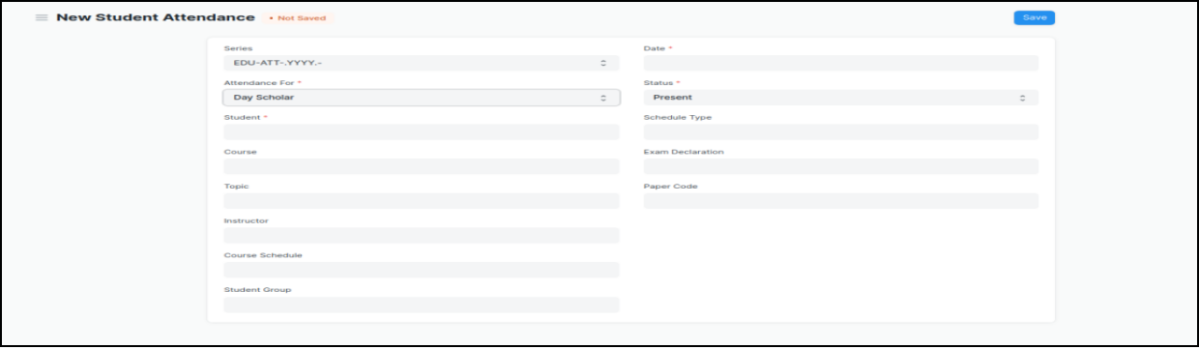

Figure 14 : Participant Attendance Screen

**Field List:**

The following table describes the UI fields present in this screen :

|  |  |  |  |  |  |  |
| --- | --- | --- | --- | --- | --- | --- |
| **ID** | **Field Name** | **Field Type** | **Validation/Action** | **Mandatory** | **Remarks** | **R/N/D** |
| 1 | Participant | Link Field | Value will be fetched from Participant list,user will select . | Yes |  |  |
| 2 | Participant Name | Read only | After selecting Participant id, this field will be  Automatically filled up. |  |  |  |
| 4 | Participant Group | Link Field | Value will be fetched from Participant group list in which the Participant is present. |  |  |  |
| 5 | Date | Date | User will select the current date | Yes |  |  |
| 6 | Status | Dropdown | Options : Present, Absent,  User will select . | Yes |  |  |
| 7 | Course | Link Field | Value will be fetched from Course list that the Participant have enrolled.User will select |  |  | ( R ) Module |
| 9 | Time | Time | Auto Fetched when attendance will take from Attendance Tool |  |  |  |

**\*\*Note: The Attendance can be marked for the Exams and also the Participant Attendance Tool can be used for bulk upgradation of the attendance.**

**Users: Roles and Permissions**

The following table describes the users and their roles and permissions for the screens :

|  |  |  |  |  |  |  |  |  |
| --- | --- | --- | --- | --- | --- | --- | --- | --- |
| **ID** | **Role** | **Read** | **Write** | **Create** | **Delete** | **Submit** | **Cancel** | **Amend** |
| 1 | ToT coordinator/director | Yes | Yes | Yes | Yes | Yes | Yes | Yes |
| 2 | ToT coordinator/administrator | Yes | Yes | Yes | Yes | Yes | Yes | Yes |
| 3 | ToT assistant coordinator/trainer | Yes | Yes | Yes | Yes | Yes | Yes | Yes |

## **Participant Attendance Tool**

**General Description**

The following table describe overall information about this screen:

|  |  |
| --- | --- |
| **Description** | The Participant Attendance Tool allows user to bulk update the Attendance for Participants based on Participant Group and Course Schedule. |
| **Navigation** | Home > Academics > Tools > Participant Attendance Tool |
| **Pre-requisites** | 1. Participant  2. Course Schedule  3. Participant Group |

**Screenshot**

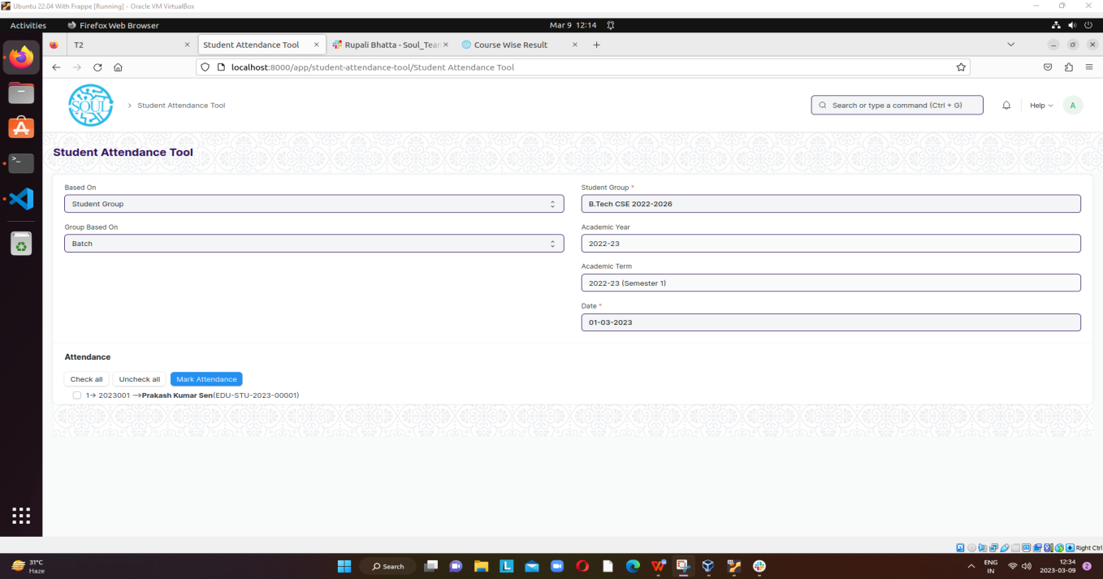

Figure 15 : Participant Attendance Screen

**Field List**

The following table describes the UI fields present in this screen :

|  |  |  |  |  |  |  |
| --- | --- | --- | --- | --- | --- | --- |
| **ID** | **Field Name** | **Field Type** | **Validation/Action** | **Mandatory** | **Remarks** | **R/N/D** |
| 1 | Based On | Dropdown | Options : Participant Group Course Schedule |  |  |  |
| 2 | Group Based On | Dropdown | Options :Batch Course Activity |  |  |  |
| 3 | Participant Group | Link Field | Value will be fetched from  Participant group list.User  Will select one. | Yes |  |  |
| 4 | Academic Year | Link Field | Value will be fetched from  Academic year,user will  Select one. |  |  |  |
| 5 | Academic Term | Link Field | Value will be fetched  Based on selected academic year. |  |  |  |
| 7 | Date | Date | User will select the date, Date should not be the future date | Yes |  |  |
| 9 | Time | Time |  |  |  |  |

**\*\*Note:**

* **In Participant Attendance Screen Participants attendance must be provided by an instructor before a specific deadline.**
* **Duplicate record will considered when date, time and Participant group name is same, if date and Participant group is same but time is different then it need to take the attendance again\*\***

**Users: Roles and Permissions**

The following table describes the users and their roles and permissions for the screens :

|  |  |  |  |  |  |  |  |  |
| --- | --- | --- | --- | --- | --- | --- | --- | --- |
| **ID** | **Role** | **Read** | **Write** | **Create** | **Delete** | **Submit** | **Cancel** | **Amend** |
| 1 | ToT coordinator/director | Yes | Yes | Yes | Yes | NA | NA | NA |
| 2 | ToT coordinator/administrator | Yes | Yes | Yes | Yes | NA | NA | NA |
| 3 | ToT assistant coordinator/trainer | Yes | Yes | Yes | Yes | NA | NA | NA |

## 

## **Assignment**

**General Description**

The following table describes overall information about this screen:

|  |  |
| --- | --- |
| **Description** | In Assignment Screen Trainers can easily provide assignment to their respective Participants, so that it gives a strong bonding between the Participants and the trainers. |
| **Navigation** |  |
| **Pre-requisites** | 1. Instructor 2. Participant Group |

**Screenshot**

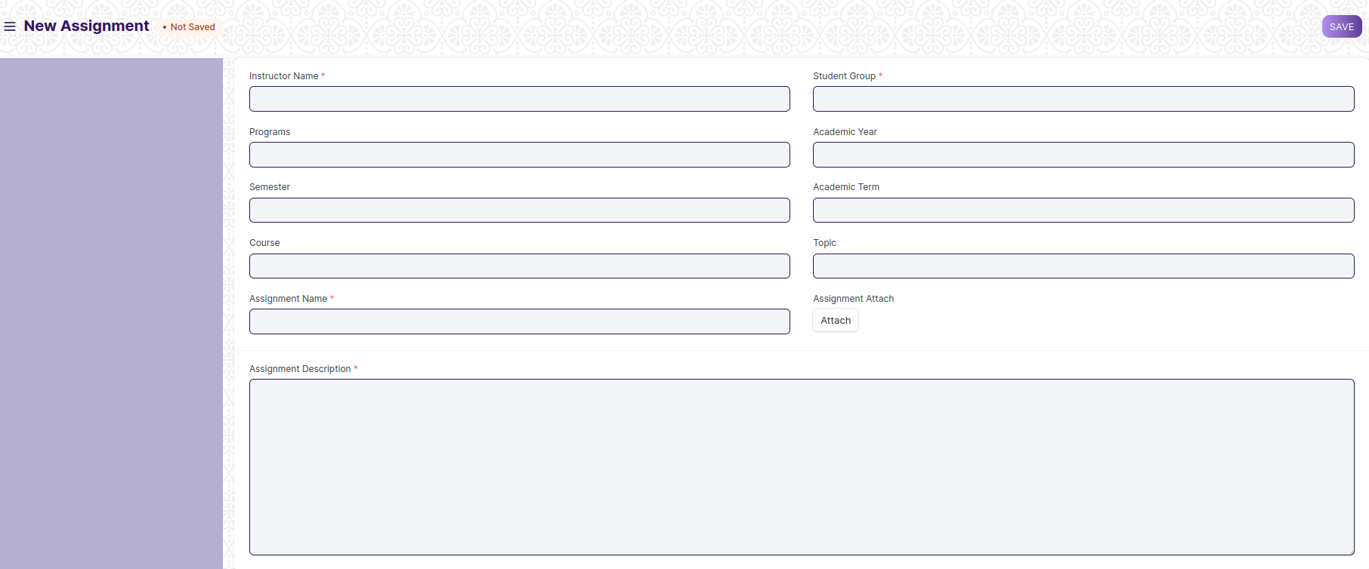

Figure 16 : Assignment Screen

**Field List**

The following table describes the UI fields present in this screen :

|  |  |  |  |  |  |  |
| --- | --- | --- | --- | --- | --- | --- |
| **ID** | **Field Name** | **Field Type** | **Validation/Action** | **Mandatory** | **Remarks** | **R/N/D** |
| 1 | Instructor Name | Link Field | Links with Instructor Screen, filters w.r.t Participant Group | Yes |  |  |
| 2 | Participant Group | Link Field | Links with Participant Group Screen | Yes |  |  |
| 3 | Programs | Link Field | It will auto fetch when Participant Group is entered, filters w.r.t Participant Group |  |  | ( R ) Course |
| 5 | Course | Link Field | It will auto fetch when Participant Group is entered, filters w.r.t Participant Group |  |  | ( R ) Module |
| 6 | Topic | Link Field | Links with Topic Screen and filters topics should come with respect to the above course field |  |  | (R) Sub Module |
| 7 | Assignment Name | Text | User Input | Yes |  |  |
| 8 | Assignment Attach Button | Attach | 1. On attachment a dialogue box will be popup where user can attach the files, images , takes the picture with the help camera and can link any URL.   If photos or images attached then the size will be maximum 200 kb. |  |  |  |
| 9 | Description | Long Text |  | Yes |  |  |
|  | Submit |  | On Submit the assignment will be able to visible only to their respective Participants. |  |  |  |

**Users: Roles and Permissions**

The following table describes the users and their roles and permissions for the screens :

|  |  |  |  |  |  |  |  |  |
| --- | --- | --- | --- | --- | --- | --- | --- | --- |
| **ID** | **Role** | **Read** | **Write** | **Create** | **Delete** | **Submit** | **Cancel** | **Amend** |
| 1 | ToT coordinator/director | Yes | Yes | Yes | Yes | NA | NA | NA |
| 2 | ToT coordinator/administrator | Yes | Yes | Yes | No | NA | NA | NA |
| 3 | ToT assistant coordinator/trainer | Yes | No | No | No | NA | NA | NA |

## 

## **Assignment Upload**

**General Description**

The following table describes overall information about this screen:

|  |  |
| --- | --- |
| **Description** | In Assignment Upload Screen Participants can easily upload their assignment and it will securely go to their respective trainers. |
| **Navigation** |  |
| **Pre-requisites** | 1. Participant Group 2. Assignment |

**Screenshot**

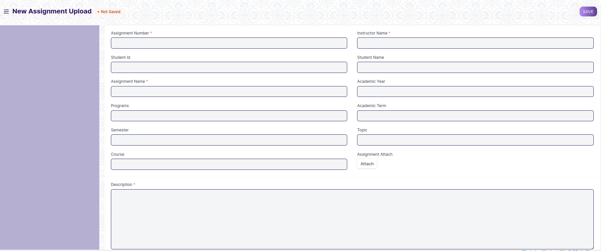

Figure 17: Assignment Upload

**Field Type**

The following table describes the UI fields present in this screen :

|  |  |  |  |  |  |  |
| --- | --- | --- | --- | --- | --- | --- |
| **ID** | **Field Name** | **Field Type** | **Validation/Action** | **Mandatory** | **Remarks** | **R/N/D** |
| 1 | Instructor Name | Link Field | Links with Instructor Screen | Yes |  |  |
| 2 | Assginment Number | Link Field | Links with Assignment Screen | Yes |  |  |
| 3 | Participant Id | Link Field | Link with Participant Screen |  |  |  |
| 4 | Participant name | Text Field | It will auto fetch when Participant Id is entered |  |  |  |
| 5 | Programs | Link Field | It will auto fetch when Participant Id is entered |  |  | ( R ) Course |
| 7 | Academic Year | Link Field | Link with Academic Year Screen |  |  |  |
| 8 | Academic Term | Link Field | Link with Academic Term and Value will be fetched based on selected Academic year. |  |  |  |
| 9 | Course | Link Field | It will auto fetch when Participant Id is entered |  |  | ( R ) Module |
| 10 | Topic | Link Field | Links with Topic Screen and filters topics should come with respect to the course |  |  | (R) Sub Module |
| 11 | Assignment Name | Text | User Entered | Yes |  |  |
| 12 | Assignment Attach Button | Attach | 1. On attachment a dialogue box will be popup where user can attach the image, take the picture with the help camera and can link any URL. 2. If photos or images attached then the size will be maximum 200 kb. |  |  |  |
| 13 | Description | Long Text |  | Yes |  |  |
|  | Submit |  | On Submit assignment will be shown only to that particular instructor. |  |  |  |

**Users: Roles and Permissions**

The following table describes the users and their roles and permissions for the screens :

|  |  |  |  |  |  |  |  |  |
| --- | --- | --- | --- | --- | --- | --- | --- | --- |
| **ID** | **Role** | **Read** | **Write** | **Create** | **Delete** | **Submit** | **Cancel** | **Amend** |
| 1 | ToT coordinator/director | Yes | Yes | Yes | Yes | NA | NA | NA |
| 2 | ToT coordinator/administrator | Yes | Yes | Yes | No | NA | NA | NA |
| 3 | ToT assistant coordinator/trainer | Yes | No | No | No | NA | NA | NA |

## Examination

## **Assignment Declaration**

**General Description**

|  |  |
| --- | --- |
| **Description** | The Assignment Declaration will allow user to declare an exam for various courses with respect to academic Year |
| **Navigation** | Home > Examination > Examination>Exam Declaration |
| **Pre-requisites** | 1. Program 2. Academic Year 3. Participant Group |
| **Existing Screen Name** | Exam Declaration |
| **New Screen Name** | NA |

### **Screenshot**

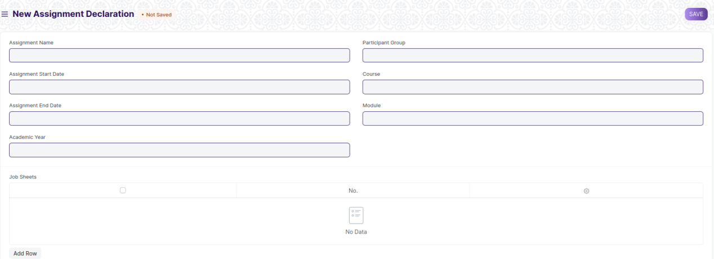

Figure 18 : Exam Declaration

### **Field List**

The “Assignment Declaration” screen shall consist of the following fields:

|  |  |  |  |  |  |  |
| --- | --- | --- | --- | --- | --- | --- |
| **ID** | **Field Label** | **Field Type** | **Validation/Action** | **Mandatory** | **Remarks** | **R/N/D** |
| 1 | Assignment Name | Text Field |  | Y |  |  |
| 2 | Assignment Start Date | Date | Start Date need to be before the End Date | Y |  |  |
| 3 | Assignment End Date | Date | End Date need to be after start date | Y |  |  |
| 4 | Academic Year | Link Field | Linked to Academic Year Screen | Y |  |  |
| 6 | Participant Group | Link Field | Linked to Participant Group Screen | Y |  |  |
| 7 | Course | Link Field | Linked to Programs Screen and auto fetched when participant group is selected |  |  |  |
| 8 | Module | Link Field | Linked to Course Screen and auto fetched when participant group selected. |  |  |  |
| 9 | Job Sheets | Table | Description of this table is given below | Y |  |  |
| 10 | Trainer Id | Link FIeld | Link to Instructor Screen and only those trainers will come who have assigned for respective Participant Group | Y |  |  |
| 11 | Trainer Name | Text Field | Trainer Name will auto fetched when trainer id entered. |  |  |  |
| 12 | Get Participant | Button | On click list of participants details will be auto fetched in the Participant list table |  |  |  |
| 13 | Participant List | Table | Description of this table is given below |  |  |  |

|  |  |  |  |  |  |  |
| --- | --- | --- | --- | --- | --- | --- |
|  | **Job Sheet** | | | | | |
| ID | **Field Label** | **Field Type** | **Validation/Action** | **Mandatory** | **Remarks** | **R/N/D** |
| 1 | Job Sheet Name | Link Field | Auto fetch based on “Get Courses” Button | Y |  | (R) Modules |
| 2 | Date | Text field | Auto fetch based on “Get Courses” Button |  |  | (R) Modules Name |
| 3 | From Time | Text field | Auto fetch based on “Get Courses” Button |  |  | (R) Modules Code |
| 4 | From Time | Time | User Input | Y |  |  |
| 5 | To Time | Time | User Input | Y |  |  |
| 6 | Total Duration (in Hours) | Time | Calculated based on “From Time” & “To Time” |  |  |  |

|  |  |  |  |  |  |  |
| --- | --- | --- | --- | --- | --- | --- |
| **Participant List** | | | | | | |
| **ID** | **Field Label** | **Field Type** | **Validation/Action** | **Mandatory** | **Remarks** | **R/N/D** |
| 1 | Participant Id | Text Field | Auto fetch based on “Get Participant” Button |  |  |  |
| 2 | Participant Name | Text Field | Auto fetch based on “Get Participant” Button |  |  |  |

**Note: A notification or mail will be sent directly to the Participant after the exam declaration are announced.**

**User: Roles & Permission**

The following table describes the users and their roles and permissions for the screens :

|  |  |  |  |  |  |  |  |  |
| --- | --- | --- | --- | --- | --- | --- | --- | --- |
| **ID** | **Role** | **Read** | **Write** | **Create** | **Delete** | **Submit** | **Cancel** | **Amend** |
| 1 | ToT coordinator/director | Yes | Yes | Yes | Yes | Yes | Yes | Yes |
| 2 | ToT coordinator/administrator | Yes | Yes | Yes | Yes | Yes | Yes | Yes |
| 3 | ToT assistant coordinator/trainer | Yes | Yes | Yes | Yes | Yes | Yes | Yes |
|  | ToT participant | Yes | No | No | No | No | No | No |

## **Assignment Evaluation**

**General Description**

|  |  |
| --- | --- |
| **Description** | Criteria Wise Evaluation allows us to create an evaluation for a particular assessment criterion in a course for a Participant enrolled in that course. |
| **Navigation** |  |
| **Pre-requisites** | 1. Assignment Declaration 2. Course 3. Assessment Criteria 4. Grading Scale |
| **New Screen Name** | Assignment Evaluation |

### **Screenshot**

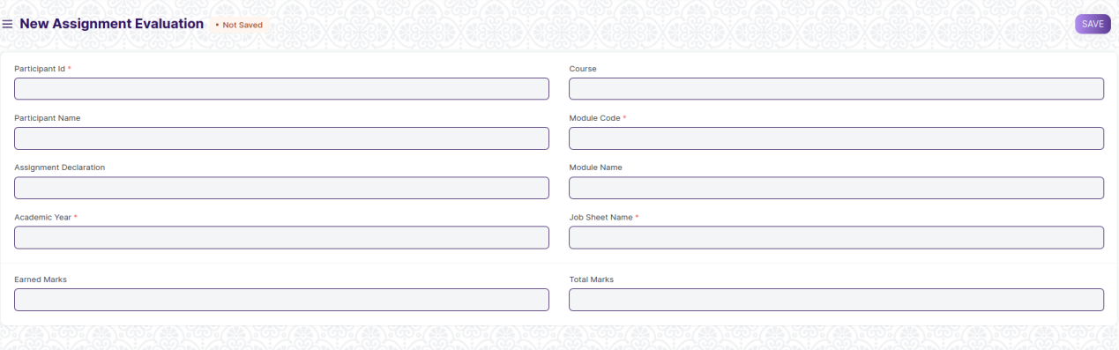

Figure 23 : Assignment Evaluation Screen

### **Field List**

The “Assignment Evaluation” screen shall consist of the following fields:

|  |  |  |  |  |  |  |
| --- | --- | --- | --- | --- | --- | --- |
| **ID** | **Field Label** | **Field Type** | **Validation/Action** | **Mandatory** | **Remarks** | **R/N/D** |
| 1 | Participant Id | Link Field | Fetched from Participant master screen | Y |  |  |
| 2 | Participant Name | Text Field | Auto fetch based on Participant |  |  |  |
| 5 | Academic Year | Link Field | Auto fetched based on selected “Exam Declaration” | Y |  |  |
| 7 | Module | Link Field | Fetched from Course master screen, filtered will be applied Participant enrolled course | Y |  |  |
| 8 | Module Name | Text Field | Auto fetch based on Course |  |  |  |
| 9 | Job Sheet | Link Field | Fetched from Assessment Criteria master screen | Y |  |  |
| 10 | Assignment Declaration | Link Field | Fetched from Assignment Declaration master screen |  |  |  |
| 12 | Course | Link Field | Auto fetched based on selected “Exam Declaration” |  |  |  |
| 15 | Earned Marks | Float |  |  |  |  |
| 16 | Total Marks | Float | Auto fetched based on selected Course from Course master |  |  |  |

### **User: Roles & Permission**

The following table describes the users and their roles and permissions for the screens :

|  |  |  |  |  |  |  |  |  |
| --- | --- | --- | --- | --- | --- | --- | --- | --- |
| **ID** | **Role** | **Read** | **Write** | **Create** | **Delete** | **Submit** | **Cancel** | **Amend** |
| 1 | ToT coordinator/director | Yes | Yes | Yes | Yes | NA | NA | NA |
| 2 | ToT coordinator/administrator | Yes | Yes | Yes | No | NA | NA | NA |
| 3 | ToT assistant coordinator/trainer | Yes | No | No | No | NA | NA | NA |

## **Assignment Evaluation Tool**

**General Description**

|  |  |
| --- | --- |
| **Description** | Assignment Evaluation Tool helps in entering marks earned by the Participants in a course for a particular module or Job sheet or particular assessment Scheme. |
| **Navigation** |  |
| **Pre-requisites** | 1. Assignment Declaration 2. Course 3. Assessment Criteria |
| **New Screen Name** | Assignment Evaluation Tool |

### **Screenshot**

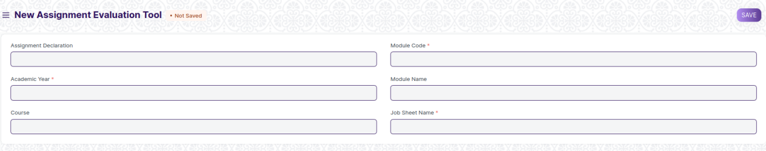

Figure 24 : Assignment Evaluation Tool Screen

### **Field List**

The “Assignment Evaluation Tool” screen shall consist of the following fields:

|  |  |  |  |  |  |  |
| --- | --- | --- | --- | --- | --- | --- |
| **ID** | **Field Label** | **Field Type** | **Validation/Action** | **Mandatory** | **Remarks** | **R/N/D** |
| 1 | Academic Year | Link Field | Fetched from Academic Year master screen | Y |  |  |
| 3 | Assignment Declaration | Link Field | Fetched from Assignment Declaration master screen and filtered applied on the basis of Semester and Academic Term |  |  |  |
| 5 | Total Participants | Number |  |  |  |  |
| 7 | Course | Link Field | Fetched from Programs master screen, filtered applied on the basis of Program Grade |  |  |  |
| 9 | Module | Link Field | Fetched from Course master screen and filtered applied on the basis of Semester | Y |  |  |
| 10 | Module Code | Text Field | Auto fetch based on Course |  |  |  |
| 11 | Module Name | Text Field | Auto fetch based on Course |  |  |  |
| 12 | Job Sheet/ Assessment Scheme | Link Field | Fetched from Assessment Criteria master screen | Y |  |  |
| 13 | **Participant Details Data** | Table |  |  | These table is describe below |  |

|  |  |  |  |  |  |  |
| --- | --- | --- | --- | --- | --- | --- |
| **Participant Details Data** | | | | | | |
| **ID** | **Field Label** | **Field Type** | **Validation/Action** | **Mandatory** | **Remarks** | **R/N/D** |
| 1 | Participant Id | HTML Field | Auto fetched when all the above relevant inputs given |  |  |  |
| 2 | Participant Name | HTML Field | Auto fetched when all the above relevant inputs given |  |  |  |
| 4 | Earned Marks | HTML Field | Auto fetched when all the above relevant inputs given |  |  |  |
| 5 | Total Marks | HTML Field | Auto fetched when all the above relevant inputs given |  |  |  |

### **User: Roles & Permission**

The following table describes the users and their roles and permissions for the screens :

|  |  |  |  |  |  |  |  |  |
| --- | --- | --- | --- | --- | --- | --- | --- | --- |
| **ID** | **Role** | **Read** | **Write** | **Create** | **Delete** | **Submit** | **Cancel** | **Amend** |
| 1 | ToT coordinator/director | Yes | Yes | Yes | Yes | NA | NA | NA |
| 2 | ToT coordinator/administrator | Yes | Yes | Yes | No | NA | NA | NA |
| 3 | ToT assistant coordinator/trainer | Yes | No | No | No | NA | NA | NA |

## **Final Assignment Result**

**General Description**

|  |  |
| --- | --- |
| **Description** | Assignment Result is used to evaluate the final assessment of a Participant for a particular semester. |
| **Navigation** |  |
| **Pre-requisites** | Assignment Evaluation |
| **New Screen Name** | Assignment Result |

### **Screenshot**

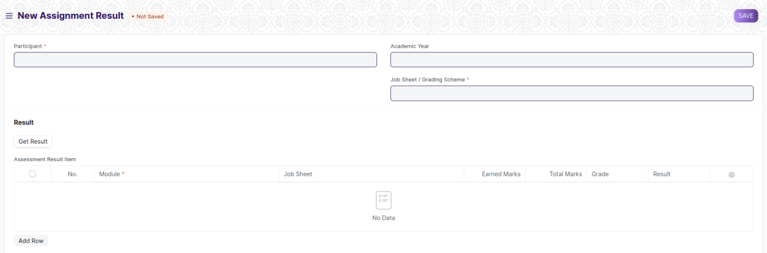

Figure 26 : Assignment Result Screen

### **Field List**

The “Assignment Result” screen shall consist of the following fields:

|  |  |  |  |  |  |  |
| --- | --- | --- | --- | --- | --- | --- |
| **ID** | **Field Label** | **Field Type** | **Validation/Action** | **Mandatory** | **Remarks** | **R/N/D** |
| 1 | Course | Link Field | Auto fetch when Participant Id is entered |  |  |  |
| 3 | Module | Link Field | Auto fetch when Participant Id is entered |  |  |  |
| 4 | Academic Year | Link Field | Auto fetch when Participant Id is entered |  |  |  |
| 6 | Participant | Link Field | Fetched from Participant master screen |  |  |  |
| 7 | Participant Name | Text Field | Auto fetch when Participant Id is entered |  |  |  |
| 10 | Grading Scale | Link Field | Fetched from Grading Scale master screen |  |  |  |
| 11 | Assessment Status | Text Field |  |  |  |  |
| 12 | Get Result | Button |  |  |  |  |
| 13 | **Assessment Result Item** | Table | After Clicking on Get Result, the **Assessment Result Item** table will auto fetch**.** |  | These table is describe below |  |
| 14 | **Evaluation Result Item** | Table | This table will visible when a record is in **Draft** Status |  | These table is describe below |  |
| 15 | Result | Text Field | Auto Calculated after saving the record |  |  |  |
| 16 | Grade | Text Field | Auto Calculated after saving the record |  |  | (N) |
| 17 | Overall Grade | Text Field | Auto Calculated after saving the record |  |  | (N) |
| 18 | Comment | Small Text Field |  |  |  |  |

|  |  |  |  |  |  |  |
| --- | --- | --- | --- | --- | --- | --- |
| **Assessment Result Item** | | | | | | |
| **ID** | **Field Label** | **Field Type** | **Validation/Action** | **Mandatory** | **Remarks** | **R/N/D** |
| 1 | Course | Link Field | Fetched from Course master screen | Y |  | (R) Module |
| 2 | Job Sheet / Assessment Scheme | Link Field | Fetched from Assessment Criteria master screen |  |  |  |
| 5 | Earned Marks | Float | Auto fetched on the basis of Get Result Button |  |  |  |
| 6 | Total Marks | Float | Auto fetched on the basis of Get Result Button |  |  |  |
| 7 | Grade | Text Field | Auto fetched on the basis of Get Result Button |  |  |  |
| 8 | Result | Drop down | Auto fetched on the basis of Get Result Button | P/F |  |  |

|  |  |  |  |  |  |  |
| --- | --- | --- | --- | --- | --- | --- |
| **Evaluation Result Item (This table will visible when the record is in draft stage)** | | | | | | |
| **ID** | **Field Label** | **Field Type** | **Validation/Action** | **Mandatory** | **Remarks** | **R/N/D** |
| 1 | Module | Link Field | Fetched from Course master screen | Y |  |  |
| 2 | Module Code | Text Field | Auto fetch based on Course |  |  |  |
| 3 | Module Name | Text Field | Auto fetch based on Course |  |  |  |
| 6 | Earned Marks | Text Field |  |  |  |  |
| 7 | Total Marks | Text Field |  |  |  |  |
| 8 | Grade | Text Field |  |  |  |  |
| 9 | Result | Drop down | P/F |  |  |  |

### **User: Roles & Permission**

The following table describes the users and their roles and permissions for the screens :

|  |  |  |  |  |  |  |  |  |
| --- | --- | --- | --- | --- | --- | --- | --- | --- |
| **ID** | **Role** | **Read** | **Write** | **Create** | **Delete** | **Submit** | **Cancel** | **Amend** |
| 1 | ToT coordinator/director | Yes | Yes | Yes | Yes | NA | NA | NA |
| 2 | ToT coordinator/administrator | Yes | Yes | Yes | No | NA | NA | NA |
| 3 | ToT assistant coordinator/trainer | Yes | No | No | No | NA | NA | NA |

## **Final Result Declaration Tool**

**General Description**

|  |  |
| --- | --- |
| **Description** | Final Result Declaration Tool is used to declare the final exam results for a particular group/batch of Participants in a semester. |
| **Navigation** |  |
| **Pre-requisites** | Assignment Evaluation |
| **New Screen Name** | Final Result Declaration Tool |

### **Screenshot**

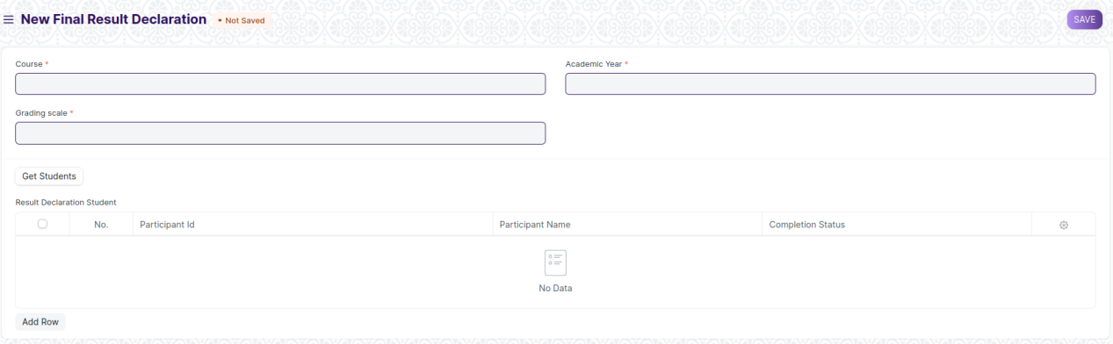

Figure 27 : Final Result Declaration Tool Screen

### **Field List**

The “Final Result Declaration Tool” screen shall consist of the following fields:

|  |  |  |  |  |  |  |
| --- | --- | --- | --- | --- | --- | --- |
| **ID** | **Field Label** | **Field Type** | **Validation/Action** | **Mandatory** | **Remarks** | **R/N/D** |
| 1 | Course | Link Field | Fetched from Programs master screen | Y |  |  |
| 2 | Academic Year | Link Field | Fetched from Academic Year master screen | Y |  |  |
| 3 | Result Creation Status | Drop Down | In Process  Failed  Successful |  |  |  |
| 4 | Get Participants | Button |  |  |  |  |
| 5 | Total Enrolled Participant | Number | Auto created when clicked on Get Participant Button |  |  |  |
| 6 | **Result Declaration Participant** | Table | Child Table: Result Declaration Participant |  | These table is describe below |  |

|  |  |  |  |  |  |  |
| --- | --- | --- | --- | --- | --- | --- |
| **Result Declaration Participant** | | | | | | |
| **ID** | **Field Label** | **Field Type** | **Validation/Action** | **Mandatory** | **Remarks** | **R/N/D** |
| 1 | Participant | Link Field | Fetched from Participant master screen |  |  |  |
| 2 | Participant Name | Text Field | Auto fetch based on Participant |  |  |  |

### **User: Roles & Permission**

The following table describes the users and their roles and permissions for the screens :

|  |  |  |  |  |  |  |  |  |
| --- | --- | --- | --- | --- | --- | --- | --- | --- |
| **ID** | **Role** | **Read** | **Write** | **Create** | **Delete** | **Submit** | **Cancel** | **Amend** |
| 1 | ToT coordinator/director | Yes | Yes | Yes | Yes | NA | NA | NA |
| 2 | ToT coordinator/administrator | Yes | Yes | Yes | No | NA | NA | NA |
| 3 | ToT assistant coordinator/trainer | Yes | No | No | No | NA | NA | NA |